Set Up Open VPN

## **About this project**

After generating the project tasks and scope this AI prompt copy them to the tasks database

Project Name: Set up Open VPN

Project Objective: Establish a secure virtual private network to facilitate remote access and enhance data protection.

My Constraints (Key Dates, Funding & Resources) are:

* Completion by the end of 2024 Q4
* No additional Funds available for this project. So therefore, must be free
* Current team members available for task allocation is only Erwin

Project Tasks:

* Research VPN Options
* Implement a VPN solution that allows users to connect to a device or a network from any other network.

Download OpenVPN latest version from <https://openvpn.net/community-downloads/>

Download the appropriate installer for your architecture. This project uses Windows 64-bit MSI installer.

Open up the installer

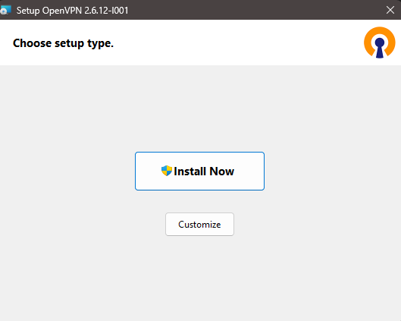

Click “Install Now”

Close the installer once its complete

You will get the following notification or error, which is fine. This is because we don’t have the config file set up. It just asking us to put in the config file in that location.

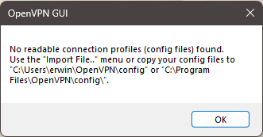

Go to <https://www.vpnbook.com/>, click OpenVPN secti and download a VPN close to you. For me currently, it is US16 Server OpenVPN Config Bundle

Right Click on your OpenVPN on your running apps thing at the bottom and go to Import → Import file… and import all the files that you downloaded.

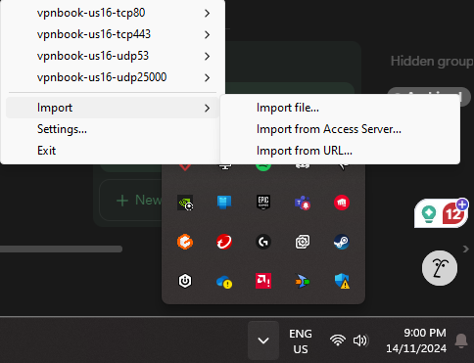

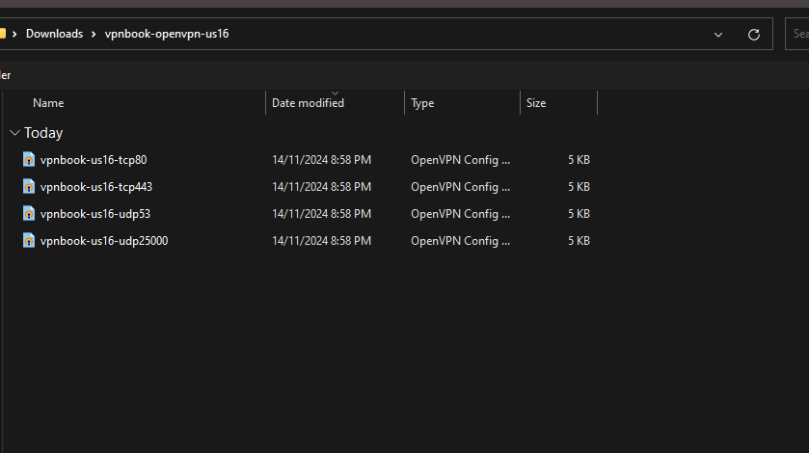

It should look like this now

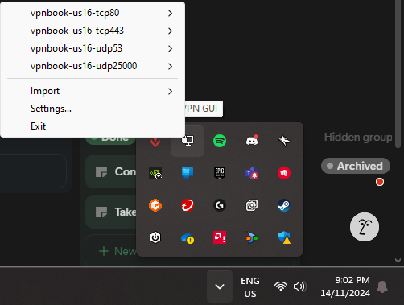

The website gave us a username and password for this as well. For us, it is:

Username: vpnbook Password: e83zu76

You can use this to connect to your VPN.

